This was advice received from Minister for Environment on 26 June 2018, regarding the recent sightings of koalas on Mt Coot-tha at Chapel Hill & Bardon locations.
Regarding the presence of koalas at the proposed site, The Department of Environment and Science has been informed by Brisbane City Council thatan experienced ecologist with a koala detection dog surveyed the zip-line site to determine the primary koala habitat areas for avoidance. This information is currently being used by Council in the final design of their proposal.
The Department’s koala sighting information is sourced by a specialized survey team who cover sites all over south east Queensland. Public sightings can be recorded via the Atlas of Living Australia which can be
accessed at: https://www.ala.org.au/. Further koala sightings in the proposal area should be directed to Brisbane City Council to inform the final project design.
It is the project manager’s (in this case Council) responsibility to follow the federal guidelines to ensure their proposal does not breach the EPBC Act. As a development application has yet to be lodged, it would be difficult for an outside party to determine if the proposal would require EPBC Act referral at this stage.
When the development application is lodged, any impacts on matters of state environmental significance will be assessed according to State policy. Additional requirements under the /Nature Conservation Act 1992/ such as requiring a spotter/catcher to be present should any clearing be required, will also be discussed with the Council.
(Following letter by the concerned resident, sent in response to the reply from the Minister for the Environment staff 26.6.18)
Koala Policy and Oversight | Conservation and Biodiversity Policy, Department of Environment and Science
Thank you for the information regarding the koala situation on Mt Coot-tha. I would like to assure you that we are not just concerned about the location of the zipline with regard to koalas. We are also concerned about the impact of:
- the increase of people movement through the regional biodiversity corridor
- the noise from the operation of the zipline and the screams of people using it
- the lighting which will continue until at least 9.30 at night.
We believe that these additional issues will cause increased stress and health issues for our vulnerable native fauna not just the koalas.
WIRES have reported that "macropods (kangaroos, wallabies and padmelons) cannot handle stressful situations, the spokesperson from WIRES said.
Stress Myopathy is a gradual breakdown of muscle tissue over a two-week period, causing increasing physical weakness until the animal is dragging itself around - a horrible way to die." Dec 2015
We have families of red-necked wallabies and swamp wallabies in the Mt Coot-tha area. I realise that your position is with Koala Policy and Oversight so I would appreciate it if you would pass on the community's concerns re other fauna who find refuge on the mountain.
KENMORE NEWS 2018
Loopholes Provide a Glimmer of Hope for Pullenvale Reserve
The Brisbane City Council has already given their approval on this proposed development. However, the Department of Natural Resources and Mines (DNRM) has reached out to the council informing them that the application has not been properly made. Full article via link.
http://kenmorenews.com.au/index.php/loopholes-provide-a-glimmer-of-hope-for-the-pullenvale-reserve/

https://www.couriermail.com.au/questnews/house-of-godfrey-riles-brisbane-residents/news-story/16924af4d213128d52205a9f7ec04dc7

Fears rezoning for development will open floodgates
Brendan O’Malley, brendan.omalley@news.com.au, Westside News
February 16, 2018 6:23pm
- Why Brissie bridge club is getting hate mail
PLANS for a church, community hall and carpark on floodprone land at Pullenvale could be the “thin edge of the development wedge’’ in the area, residents claim.
The Kenmore Presbyterian Church project, which would be built by prominent LNP fundraiser Godfrey Mantle’s company the Mantle Group, would require rezoning the rural residential property, on the corner of Pullenvale and Moggill roads.
Longtime resident Deborah Tabart feared a rezoning could make it easier for the controversial Kenmore Bridge Club project at nearby Pullenvale Reserve to gain Council approval.
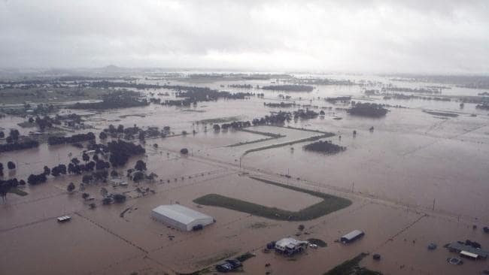
Floodwaters in the Pullenvale area, west of Brisbane, during the 2011 floods.
Ms Tabart, who heads up the Australian Koala Foundation but said she was speaking purely as a concerned resident, said the development application argued that part of Pullenvale should be considered a fringe area for more intense development.
“The implications of that word are huge. Even the (adjacent) garden centre and cafe is still zoned rural residential,’’ she said.
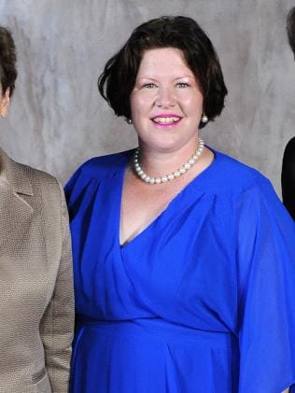
Cr Kate Richards.
Councillor Kate Richards (Pullenvale) said all potential impacts “will be closely examined as part of the assessment process’’.
A Brisbane City Council spokesman said Mr Mantle, an Elder of the church, was not the proponent nor the property owner.
“Mr Mantle is a voluntary, unpaid member of Council’s CBD Economic Advisory Board, which consists of CBD property and business owners and other stakeholders. The sole purpose of this Board is to provide ideas and feedback, limited to economic and marketing opportunities within the Brisbane CBD,’’ he said.
“Any individual or company is entitled by State Government law to submit a development application for any part of the city and is entitled to an independent assessment of the application by Council officers, against Council and State Government planning regulations.
“Council has received a development application from the Presbyterian Church of Queensland for a community facility, a church, at 2377 Moggill Road Pullenvale.
“This application is currently under assessment, however, Mr Mantle is neither the applicant nor the land owner of this property.’’
Church minister, Rev Steve Blencowe, denied claims from some residents that a traffic bottleneck would be created by people turning right off Moggill Rd.
Its traffic study was done on Sunday morning when, he said, expected usage would be greatest, he said.
He also said there was no connection with a development application involving a carpark at the adjacent Wild Canary Cafe, lodged about the same time, and said the church’s carpark was for church use only.
Mr Blencowe said only about five mature trees would be cut down and the church was for church use only.
Mr Blencowe said only about five mature trees would be cut down and the church was happy to plant replacement koala food trees.
Other Resources
Australian Koala Foundation
https://www.savethekoala.com/about-koalas/koala-habitat
Koala Facts
https://www.ehp.qld.gov.au/wildlife/koalas/koala-ecology.html
eg. Ranging Habits 1 – 135 klms in SE QLD

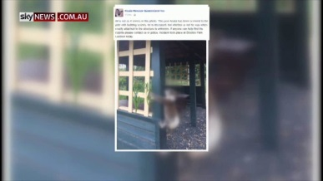
Koala cruelty calls for tougher laws
Sky News.com.au

